LIST OF TEXT BOOK

Faculty | Engineering | Date/Rev. | 21 June 2017/02/SuH
Study Program | Computer Science | Academic Year | 2017-2018

For Semester 5
No | Book Cover | Subject | Book Title | Edition | Author  (last name) | Publisher | ISBN | Price  (IDR)
1 |  | English 5 | Handout |  |  |  |  | _
2 | 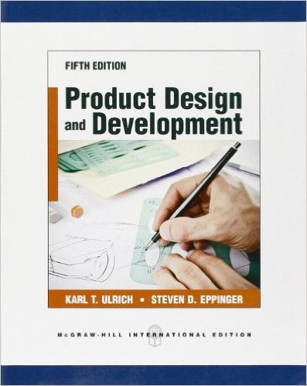 | Innovation and Product Development | Product Design and Development | 5 | Karl T. Ulrich and Steven D. Eppinger | McGraw-Hill | 9780073404776 | _
6 |  | Engineering Economy | Engineering Economy | 16 | William G Sullivan | Pearson | 9780073376301 | -
3 |  | System Design 1 | Mechatronics: Electronic Control Systems in Mechanical and Electrical Engineerin | 6th | W. Bolton | Pearson | 9781292076683 | -
3 | 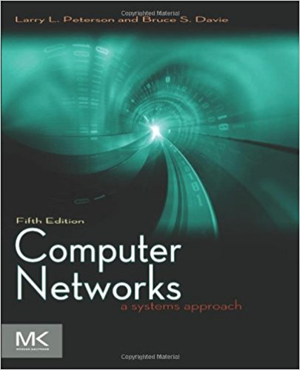 | Networking 2 | Computer Neworks: A Systems Approach (The Morgan Kaufmann Series in Networking) | 5th | Larry L. Peterson, Bruce S. Davie | Morgan Kaufmann | 9780123850591 | -
3 |  | Operations Research | Operations Research: An Introduction | 9 | Hamdy A. Taha | Pearson | 9780131391994 | -
3 |  | Software Engineering 2 | Software Engineering: A Practitioner's Approach | 7th | Roger Pressman | McGraw-Hill | 9780073375977 | -
3 | 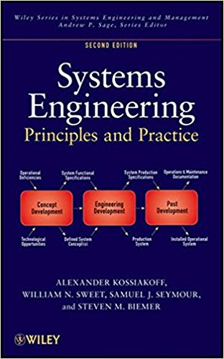 | Computer Science and System Design 1 | Systems Engineering Principles and Practice | 2nd | Alexander Kossiakoff, William N. Sweet, Samuel J. Seymour, Steven M. Biemer | Wiley | 9780470405482 | -
3 |  | IT Security 2 | Network Security: Private Communication in a Public World | 2nd | Charlie Kaufman, Radia Perlman, Mike Speciner | Prentice Hall | 9780130460196 | -
4 |  | Ethics & Religious Philosophy | Handout |  |  |  |  | -
5 |  | German Language 5 | Studio D A2: Deutsch als Fremdsprache |  | Niemann | Katalis | 9789798060670 | -
Total Price (IDR) |  |  |  |  |  |  |  | -

Proposed by: |  | Prepare by: |  | Checked by: |  | Approved by:
Date
Study Program |  | Library |  | Faculty |  | Rector

